Best wishes to Captain John for his Captain’s Day today.
Captain’s Corner

Good afternoon golfers, and a very warm welcome to Rathsallagh Golf Club for Captain’s Day 2025. Hopefully, the weather gods will be kind to us today as this is a long and difficult golf course on the best of days, but I am sure you are all well up for the challenge no matter what
the conditions.

I am delighted to say that it looks like we will have another big turnout today with over 30 players lining out, and while I am sure it will be seriously competitive out there I hope everyone has fun and enjoys the day and the company as well as the golf. Our prize-winners will have certainly proved their worth by coming out on top today.

Congratulations to Diarmuid McCarthy on his great win at our last outing In Portarlington. Diarmuid is our 3rd first time Crooked Stick winner this year (so far) and it is great to see new names making it on to our all-time winners’ list. Maybe we will have a first time Captain’s winner today?

As you will see elsewhere on this newsletter the GOY and Team competition are all still up for grabs but today is a day where the current leaders can solidify their positions, if they can
withstand the pressure!! or is it moving day for someone in the chasing pack?

The very best of luck to all you golfers today and as always, I hope you all have a very enjoyable outing, and I look forward to seeing you for dinner and chat after golf.

John

Today’s Competition
Prizes will be awarded today for:
- 1st and 2nd overall
- 3 category prizes* (low, middle, and high handicaps)
- There will also be minor prizes for:
  - Par 3s
  - Par 5s
* If there are less than 18 players then only 2 category prizes will be awarded.

A special thanks to John McLoughlin for sponsoring today’s outing.

Remaining Outings 2025

11th October | Baltinglass (11am)
27th December | Newbridge (10am)

Results – Portarlington – 9th Aug.

1st | Diarmuid McCarthy (27) | 33 pts
Cat. 1 | Brian Fitzsimons (10) | 32 pts
Cat. 2 | Christy Dowling (31) | 32 pts

Previous Winners 2025
March | Tulfarris | Dermot Griffin
April | Coollattin | David Sargent
May | Lisheen Spr. | Brian Fitzsimons
June | Arklow | Dan Corry
July | Palmerstown | Colin Sheridan

Portarlington Winners

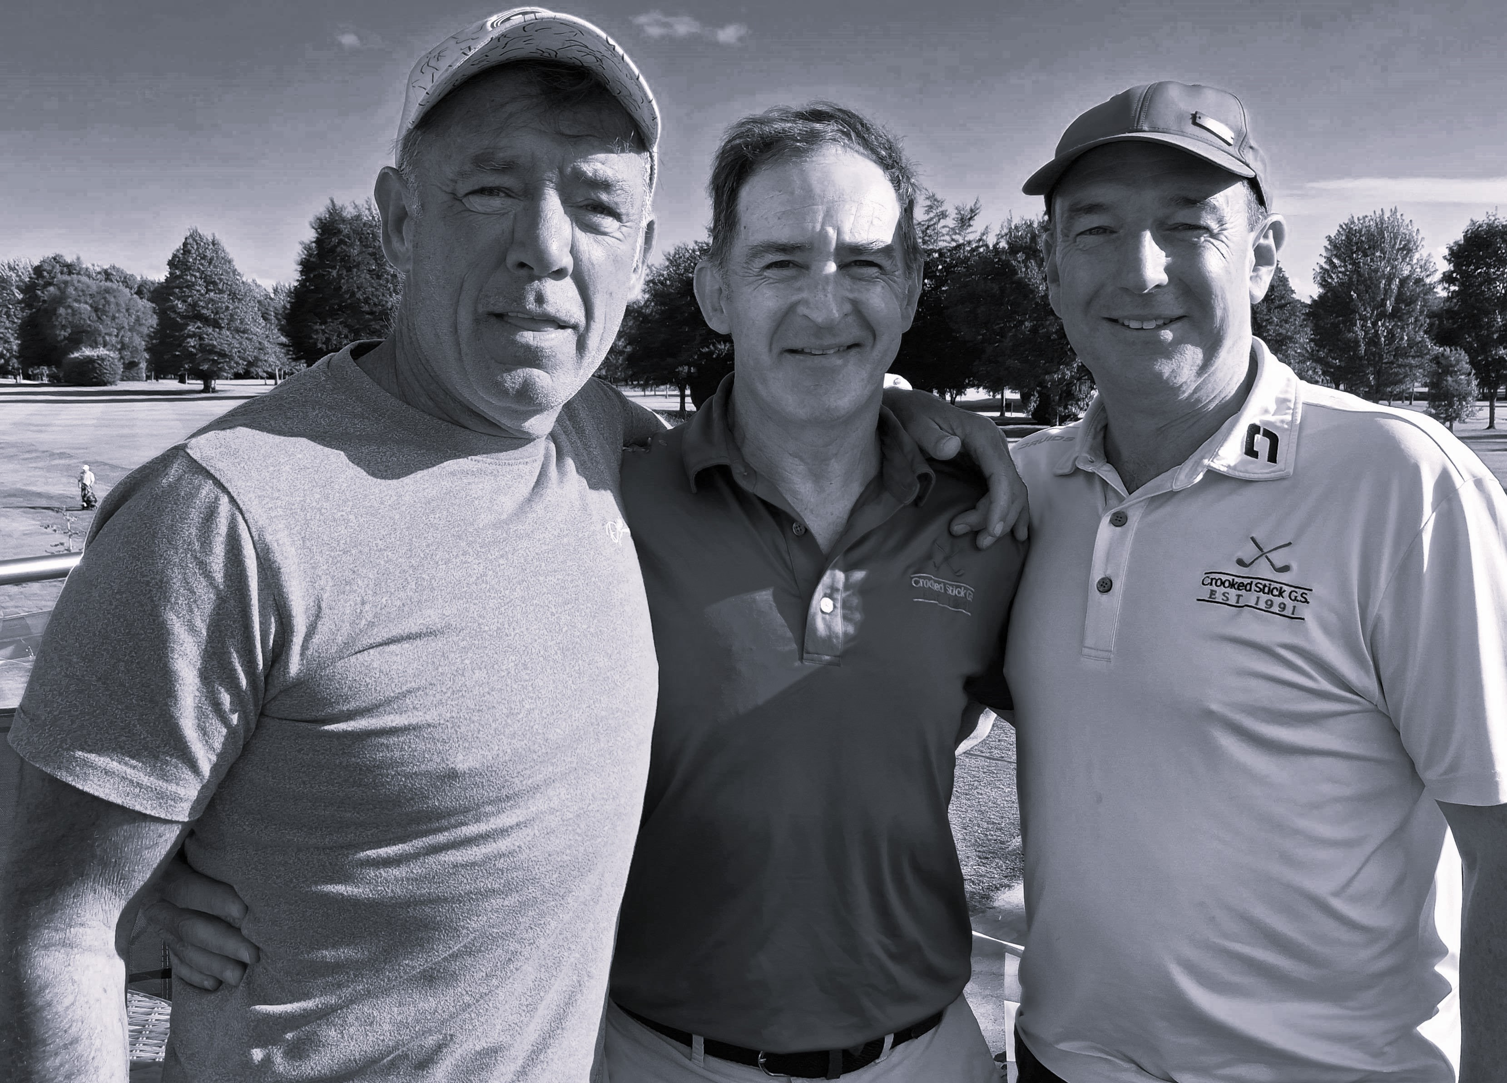
Winners: Brian Fitzsimons (category 1), Diarmuid McCarthy (overall), and Christy Dowling (category 2).

Captain’s Day winners
2002 - Kilkea Castle - Brian Devine
2003 - Kilkea Castle - Paul Byrne
2004 - Kilkea Castle - Paul Byrne
2005 - Kilkea Castle - Cathal Dunne
2006 - Rathcore - Mark Judge
2007 - Millicent - Mark Judge
2008 - The Curragh - Joe Reilly
2009 - Moyvalley - Rory Fitzsimons
2010 - Rathsallagh - Cathal Dunne
2011 - Palmerstown - David Sargent
2012 - Mt. Wolseley - Eamonn Byrne
2013 - Tullamore - Kieran O’Flaherty
2014 - Bunclody - Fergus Phelan
2015 - K-Club (Smurfit) - Brian Fitzsimons
2016 - Mount Juliet - Kieran O’Grady
2017 - Killeen - David O’Brien
2018 - Kilkea Castle - Micheál Conneff
2019 - Millicent – Brian Devine
2021 - Bunclody - Micheál Conneff
2023 - Tulfarris - Paul Burke
2024 - Millicent - Kieran O’Flaherty

Team Competition 2025
Best four counting scores from first six outings with next best score in ( ) :

1 Baltray 184
(John McLoughlin, David Sargent, Dan Corry)
2 Lahinch 143
(Paul Byrne, Mark Judge, Kevin Gibb)
3 Waterville 142
(Mick Fitzpatrick, Mick Kenny, Mark Graham)
4 Ballybunion 136
(Kieran O'Flaherty, Liam McLoughlin, Conor Holmes)
5 Portmarnock 126
(Dave O'Brien, Frank Brady, Diarmuid McCarthy)
6 Royal Portrush 118
(Micheál Conneff, JP Holligan, Joe Corrigan)
7 Royal County Down 117
(Gerry Byrne, Declan Mallon, Paul Burke)

Today’s outing and October’s outing will both count.

Golfer-of-the-Year 2025
1 Brian Fitzsimons – 81pts
2 John McLoughlin – 69pts
3 Dan Corry – 61pts

“Horses for Courses” - Rathsallagh – Previous winners
2023 – Paul Byrne
2022 – Seamus Lenehan
2021 – Mark Judge
2013 – Gerry Byrne
2011 – Ger Brady
2010 – Cathal Dunne
2009 – Mick Kenny
2008 – Ger Brady
2007 – Gerry Colclough

