Captain’s Corner

Good morning golfers and welcome to Baltinglass Golf Club for our penultimate outing of 2025. Our last visit to Baltinglass GC was way back in 2008 with Kieran Grainger being the winner.

I would like to take this opportunity to thank you all for a great turnout on our Captain’s Day outing in Rathsallagh GC and indeed for the high turnout of players at all our outings in 2025. Every outing has been hugely competitive with the winners really proving their worth. I hope everyone enjoyed the day in Rathsallagh and a big congratulations to Martin Cummins on his first Crooked Stick Captain’s prize win and also to all the other prize-winners on the day.

Congratulations also to our Golfer-of-the Year for 2025, Brian Fitzsimons, whose very fine performances throughout this year have enabled him to wrap up the GOY title with an outing in hand. Very well done, Brian, and enjoy your well-earned “Lap of Honour” today.

As you will see elsewhere in this newsletter the Team competition is still up for grabs with the Baltray team, who have led the field since our first outing in March, attempting to hold the chasing pack at bay but all could change
today!

Finally, a big thank you to the Organising Group, Gerry, Liam and Martin for all their help and guidance throughout my year as Captain and especially a big thank you to all you Crooked Stick members who made this a very easy and enjoyable year for me as Captain.

Best of luck today and enjoy,

John

Today’s Competition
Prizes will be awarded today for:
- 1st and 2nd overall
- 3 category prizes* (low, middle, and high handicaps)
* If there are less than 18 players then only 2 category prizes will be awarded.

The Memorial Trophy will be presented to today’s winner.

Remaining Outings 2025

27th December | Newbridge (10am)

Results – Rathsallagh – 13th Sep.

1st | Martin Cummins (13) | 36 pts
2nd | Brian Fitzsimons (9) | 36 pts
Cat. 1 | Jack Brady (2) | 34 pts
Cat. 2 | Frank Brady (17) | 33 pts
Cat. 3 | Christy Dowling (29) | 35 pts
Par 3s | Diarmuid McCarthy (23) | 10 pts
Par 5s | Dave O’Brien (15) | 8 pts

Previous Winners 2025
March | Tulfarris | Dermot Griffin
April | Coollattin | David Sargent
May | Lisheen Spr. | Brian Fitzsimons
June | Arklow | Dan Corry
July | Palmerstown | Colin Sheridan
Aug. | Portarlington | Diarmuid McCarthy

Rathsallagh Winners
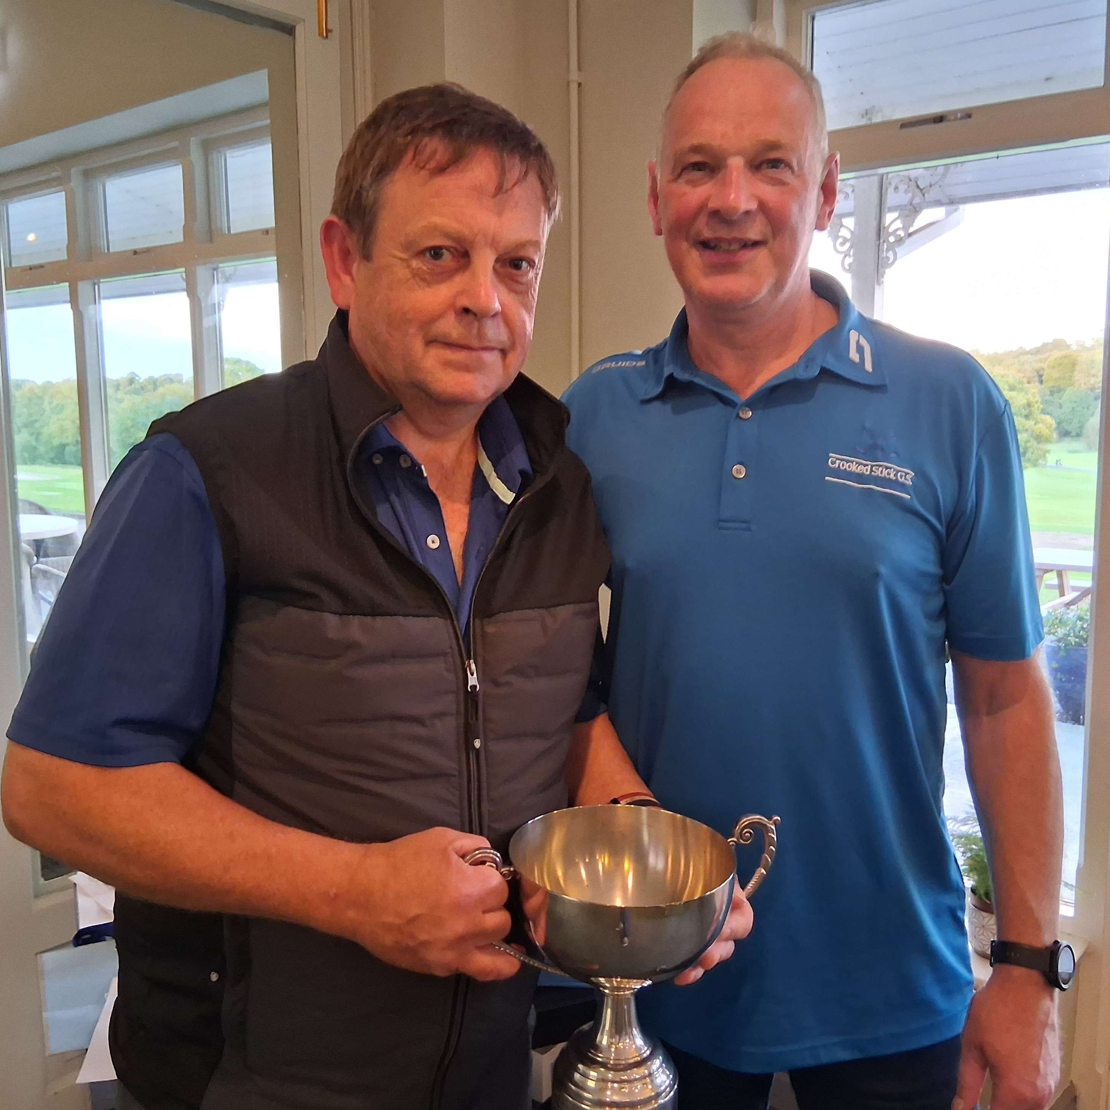
Winner: Martin Cummins receives the Perpetual Trophy from Captain John.
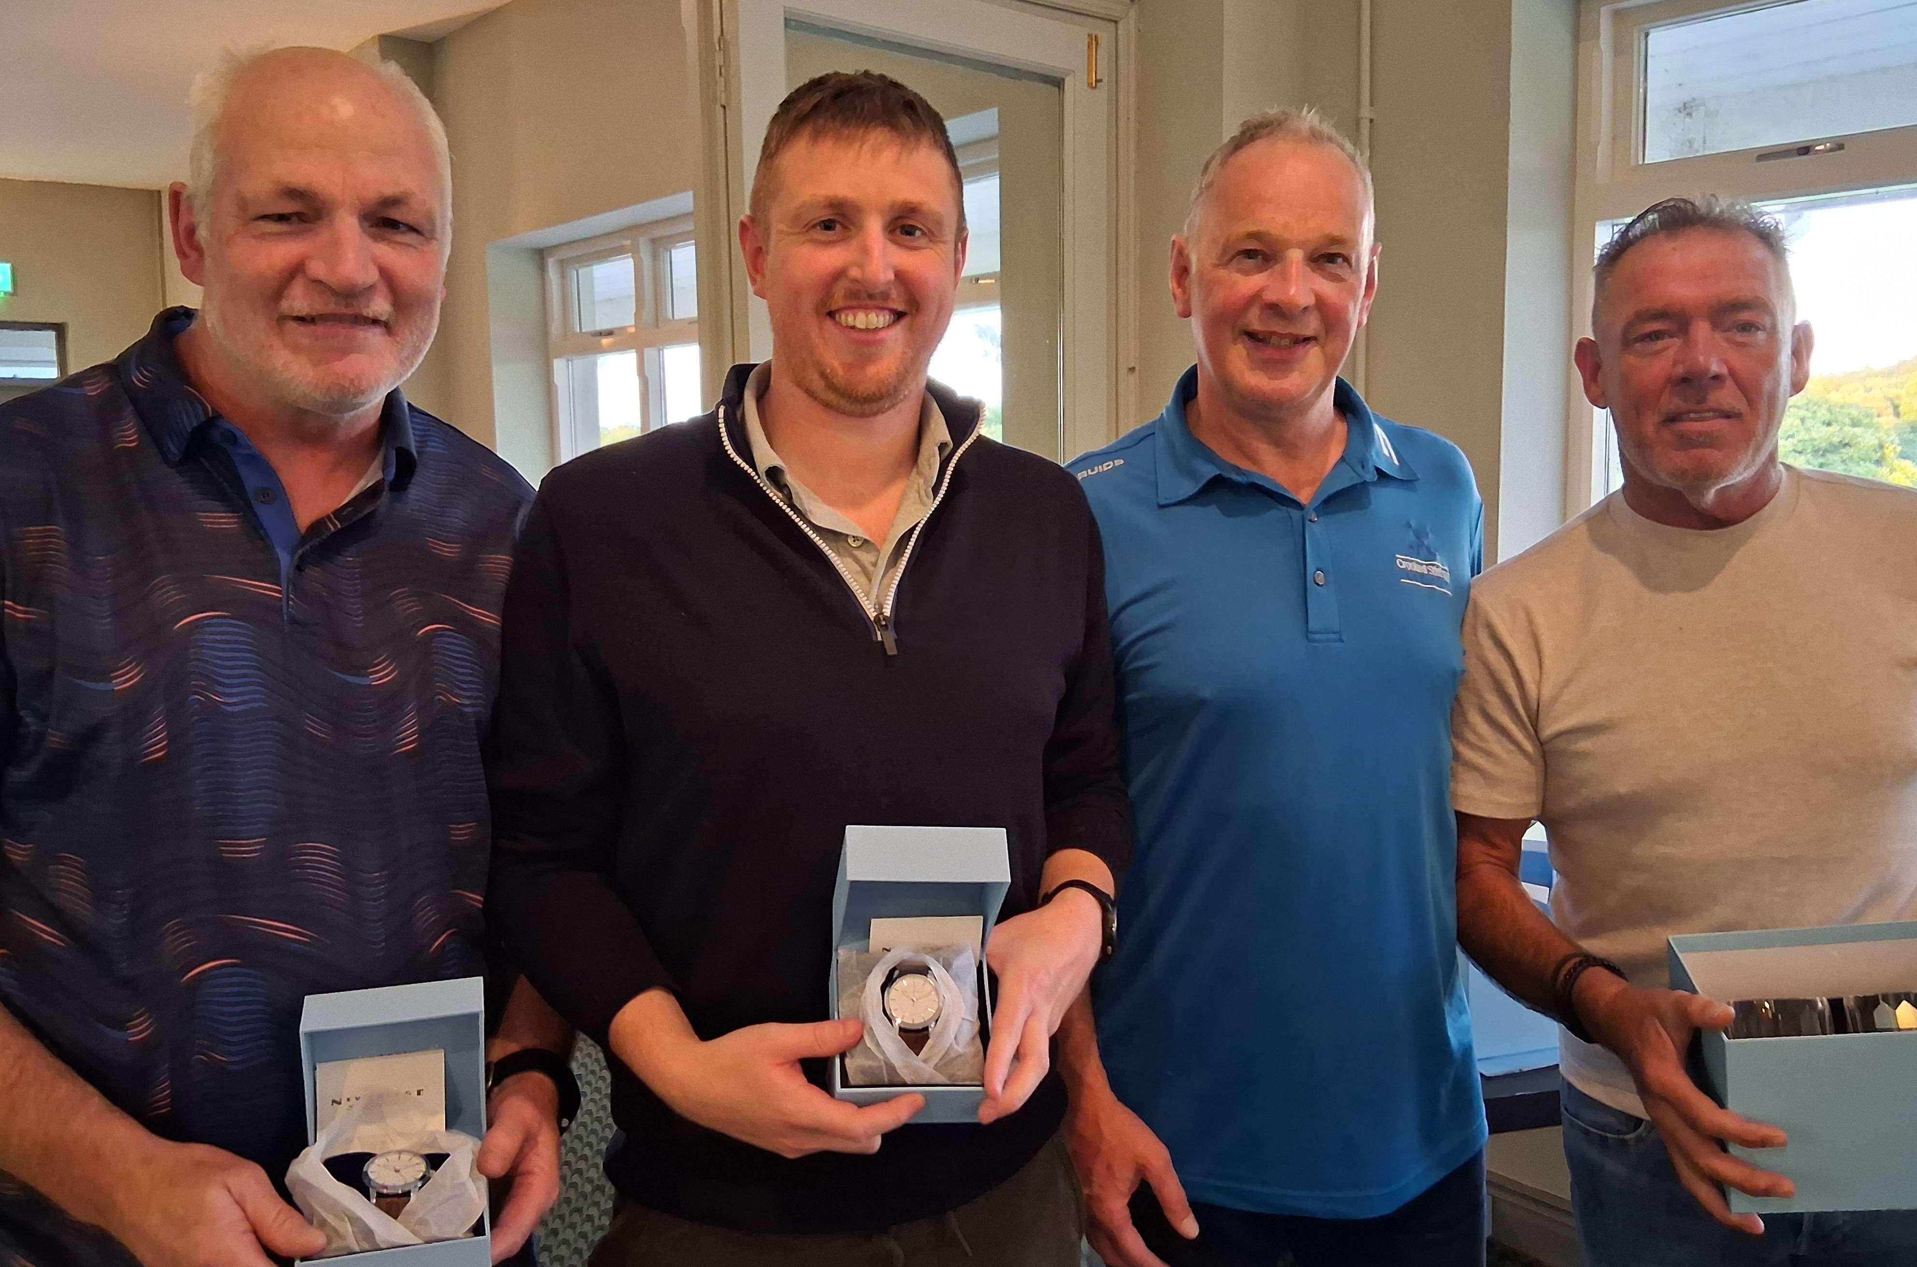
Winners: Frank Brady (category 2), Jack Brady (category 1), Captain John McLoughlin, and Brian Fitzsimons (r-up)
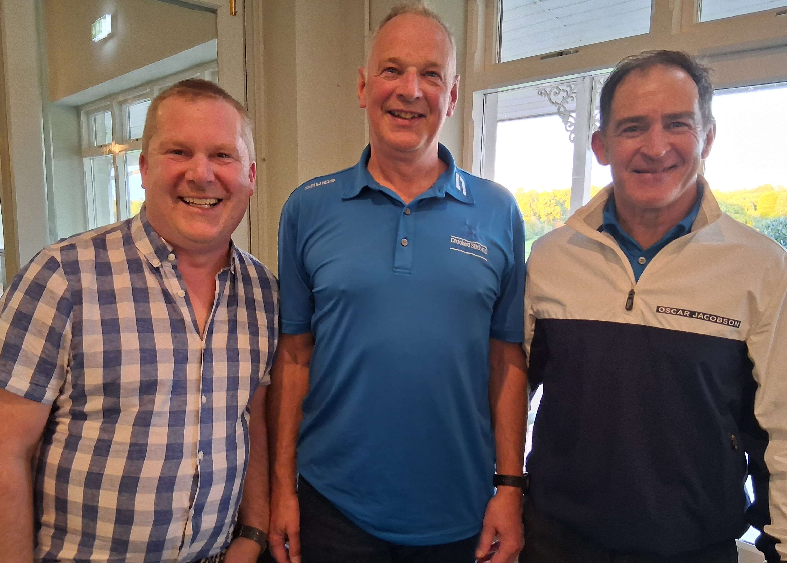
Winners: Dave O’Brien (par 5s), Captain John McLoughlin, and Diarmuid McCarthy (par 3s)

Team Competition 2025
1 Baltray 211
(John McLoughlin, David Sargent, Dan Corry)
2 Lahinch 183
(Paul Byrne, Mark Judge, Kevin Gibb)
3 Ballybunion 179
(Kieran O'Flaherty, Liam McLoughlin, Conor Holmes)
4 Portmarnock 173
(Dave O'Brien, Frank Brady, Diarmuid McCarthy)
5 Waterville 169
(Mick Fitzpatrick, Mick Kenny, Mark Graham)
6 Royal County Down 156
(Gerry Byrne, Declan Mallon, Paul Burke)
7 Royal Portrush 128
(Micheál Conneff, JP Holligan, Joe Corrigan)

Today’s outing is the final counting outing.

The Baltray team is in a very strong position. However, with the possibility of a team scoring up to 49 points today, mathematically, any of the top six teams can win but it will require two very high finishes today to challenge and overtake Baltray.

Golfer-of-the-Year 2025
1 Brian Fitzsimons – 101pts
2 Martin Cummins – 70pts
3 John McLoughlin – 69pts

With one outing remaining, Brian Fitzsimons is the Golfer-of-the-Year for 2025. Well played Brian.

